CSA0502 – QUERY PROCESSING FOR DATASCIENCE
Lab Programs

13. Detect Missing Values
Aim
To detect missing values in a given DataFrame and display True or False.
Code
import pandas as pd
import numpy as np

data = {
"Name": ["Alice", "Bob", "Charlie", "David"],
"Age": [21, np.nan, 23, 24],
"Marks": [85, 90, np.nan, 88]
}

df = pd.DataFrame(data)

print("Original DataFrame")
print(df)

print("\nMissing Values (True/False)")
print(df.isnull())
Output
Original DataFrame

Name Age Marks
0 Alice 21.0 85.0
1 Bob NaN 90.0
2 Charlie 23.0 NaN
3 David 24.0 88.0

Missing Values (True/False)

Name Age Marks
0 False False False
1 False True False
2 False False True
3 False False False
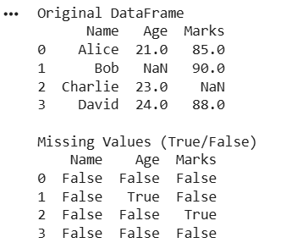
Result
The missing values were detected successfully using isnull().

14. Replace Missing Values
Aim
To find and replace missing values in a DataFrame.
Code
import pandas as pd
import numpy as np

data = {
"Name": ["Alice", "Bob", "Charlie", "David"],
"Age": [21, np.nan, 23, np.nan],
"Marks": [85, 90, np.nan, 88]
}

df = pd.DataFrame(data)

print("Original DataFrame")
print(df)

# Replace missing values
df.fillna(0, inplace=True)

print("\nDataFrame After Replacing Missing Values")
print(df)
Output
Original DataFrame

Name Age Marks
0 Alice 21.0 85.0
1 Bob NaN 90.0
2 Charlie 23.0 NaN
3 David NaN 88.0

DataFrame After Replacing Missing Values

Name Age Marks
0 Alice 21.0 85.0
1 Bob 0.0 90.0
2 Charlie 23.0 0.0
3 David 0.0 88.0
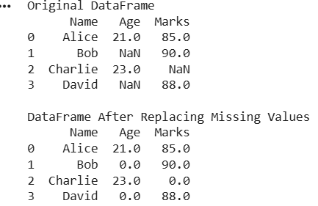
Result
Missing values were successfully replaced with 0.

